**Matching of fiducial lines to slice intersection points in ultrasound images**

Alexis Boucharin, Andras Lasso, Csaba Pinter, Tamas Heffter, Gabor Fichtinger

*Laboratory for Percutaneous Surgery, Queen’s University, Kingston, Ontario, Canada*

***Abstract***

**PURPOSE**: Effective ultrasound-guided radiation therapy of prostate cancer requires accurate calibration and quality assurance of the imaging system. These test procedures in current clinical practice are mostly performed manually, they are time consuming, often require special operator skills, and the results may be operator-dependent. The methods usually require imaging of precisely manufactured test objects (phantoms). Current computational methods typically work with one specific phantom. As development of calibration and quality assurance procedures is an active area of research, the methods and the phantoms often require changes. The coupling of the computational methods to specific phantoms and the need for manual tuning of the methods considerably slows down the development process. **METHODS**: We propose an automatic method that can decouple phantom and software changes, allowing calibration and quality assurance procedures performed on different phantoms without any software change. The idea is to introduce a phantom description scheme to specify the features of the phantom and create generic algorithms that perform all parameter tunings internally, automatically, by utilizing the information in the phantom description. We applied this approach to implement a phantom-independent version of the fiducial point segmentation algorithm developed by Chen et al. in 2009. Open-source software components were used for the implementation: the Insight Toolkit for data processing, and the 3D Slicer application for visualization and testing. **RESULTS**: Our tests on real ultrasound data sets have given promising results: the method successfully identified various fiducial line patterns that are typically used for calibration and is capable of identifying patterns commonly used in image quality assurance phantoms, all without any software change. The method also provides a speed-up in computation time up to 21% depending on the data sets.

*Index terms: ultrasound imaging, quality assurance, calibration, prostate brachytherapy.*

***Purpose***

Ultrasound-guided low dose rate brachytherapy is one of the popular choices for treatment of early prostate cancer (Jemal, 2009). During the treatment procedure radioactive seeds are permanently implanted into the cancerous prostate region. To deliver the prescribed radiation dose to the tumor and minimize irradiation of healthy tissues, the ultrasound system must provide accurate and reliable information about the prostate and seed positions. This requires accurate calibration and image quality assurance procedures. In current clinical practice, these procedures are lengthy, manual methods, often requiring an operator with special skills and experience, and the results may be operator-dependent. These limitations could be resolved by automating these procedures. Yet, this automation is a challenging task, requiring research and extensive development work.

One of the most important components of an ultrasound calibration and image quality assurance system is the measurement phantom. The phantom is an object that can be imaged by the ultrasound device and contains a number of precisely manufactured features, which provide ground truth data for various measurements. The CIRS phantom model 45 is one of the most commonly used phantom for endorectal probes (Pfeiffer, 2008). Unfortunately, currently there is no single phantom that is suitable for performing all the required tests fully automatically. Development of these automatic methods and corresponding phantoms require extensive research work. Typically new software algorithm needs to be developed and tuned for each phantom version, often performed by a trial and error process. This is time-consuming and does not guarantee optimal results.

We propose a method that helps this research and development work by not requiring any software changes when using different phantom versions. Automatic segmentation of fiducial lines is an essential feature in many calibration and image quality assurance methods.

***Methods***

1. *Overview*

Phantoms often include fiducial lines in known positions. Typically each line appears as a point in the ultrasound image and their detection provides a ground truth position for the calibration (Chen, 2009) and image quality assurance (Pfeiffer, 2008). We focused on developing algorithms that support the general solution of this problem and enable detection of coplanar lines that can be contained in multiple planes for any number of lines per plane. We first extracted a list of points that were potential intersection of fiducial lines, using the method described in (Chen, 2009). Then the fiducial points in the image plane were registered to the actual fiducial lines in the phantom. Some calibration and quality assurance parameters are automatically computed using this correspondence of fiducial line positions in the phantom and in the image space.

1. *Phantom definition*

The exact locations and basic structures (such as parallel or Z-shaped pattern) of the fiducial lines are described in a *phantom definition file*. The number of these structures is not limited and is provided in the phantom definition file. The XML format was chosen for its simplicity to be interpreted by both humans and computers and because it is a widely supported, standard file format.

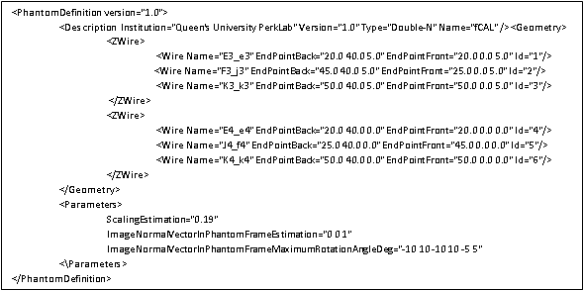

Figure 1: Example of a phantom definition xml file.

1. *Generic method for fiducial pattern recognition*

Assuming each fiducial pattern consists of coplanar lines – as it is the case in most phantoms, such as (Chen, 2009) and (Pfeiffer, 2008) – one pattern always appears in the ultrasound image as *n* collinearpoints (*n*-point line). From the list of fiducial points, *n*-point lines are computed and sorted by their intensities so that we have a list of lines each made of *n* fiducial points. Then, we perform a backtracking algorithm on these *n*-point lines to match the actual lines from the phantom definition file. The choice for a backtracking algorithm is its simplicity and the fact that there are not too many candidate lines so the computation time of this part of the method is not predominant. Once the lines are correctly detected, we can determine from the image orientation and a transform matrix the correspondence between the detected fiducial points and the ones defined in the phantom definition file and thus register them to the labels provided in the phantom definition file.

The criteria to accept points on a line or to register a potential line to an actual one by the backtracking algorithm are automatically computed internally by the algorithm. From the angular maximum movements of the ultrasound probe, we can determine how far from the actual position the candidate line can be. This angular maximum movement provides the range in which the image can actually be, as the image plane might not necessarily be perpendicular to the fiducial lines due to small probe rotations, or could be slightly rotated around one axis or the other. These angular parameters are obtained from the phantom definition file and the input data and would allow an optimal choice of threshold parameters that are automatically determined for any line configuration in the phantom. From these angles we estimate the range of potential image plane positions and orientations by applying three rotations, one around each phantom coordinate system axis. Then we compute the intersection of the fiducial plane, defined by three wires in a Z-shape configuration or by parallel lines, and the image plane. Then compute the maximum and minimum possible inclination of the intersection line in the image plane. This computation provides us automatically two important segmentation parameters with high accuracy.

1. *Implementation*

The method has been developed in C++, using the **Insight Segmentation and Registration Toolkit** (ITK, http://www.itk.org/) for speed, robustness, extensibility, and portability. A 3D Slicer (http://www.slicer.org/) module has been developed for visualization of input data and results. This module was extensively used for software debugging, testing, and creation of ground truth data sets for automatic testing. A screenshot of the 3D Slicer module is shown in Figure 2.

The algorithm is automatically tested every night using the CTest/CDash testing framework, which provides a consistent tool for testing and analyzing the performance of the method (success rate, speed of computation).

***Results and discussion***

The automatic computation of selected segmentation parameters and minimum and maximum angle of a line in the image plane has been successfully tested on 5 image sequences acquired by different ultrasound systems. With the automatic parameter computation the success rate of the fiducial segmentation and line detection remained 100% and in some cases it considerably reduced the computation time (see Table 1).

Using the automatic method the computation time was very slightly decreased (by about 1%) in 4 out of 5 cases, while in one case the computation time was reduced by 21%. In this latter sequence the image noise was higher than in the other data sets, therefore the number of candidate fiducial points was high, which increased the number of lines computed. The manually chosen inclination parameters allowed a wide range of lines, so by tightening this range via our automatic computation, we reduced the number of lines we accepted and saved a large amount of computation time.

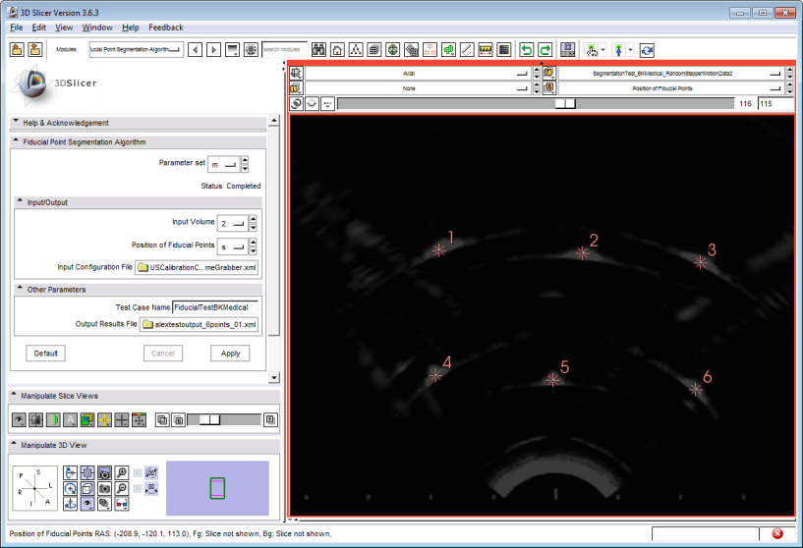 Figure 2: 3D Slicer module of a segmented ultrasound image. The fiducial points are labelled.

|  |  |  |  |
| --- | --- | --- | --- |
| *Data sets* | *Manual method runtime (sec)* | *Automatic method runtime (sec)* | *Reduction in runtime* |
| 1 | 7.04 | 7.01 | 0.5% |
| 2 | 4.73 | 4.72 | 0.3% |
| 3 | 2.28 | 2.27 | 0.3% |
| **4** | **20.25** | **15.92** | **21.4%** |
| 5 | 3.57 | 3.55 | 0.3% |

Table : Average run times (repeated 10 times) of manual and automatic methods for tolerance parameters and speed-up.

***Conclusion***

In conclusion the method successfully identified various fiducial line patterns that are typically used for calibration and is capable of identifying patterns commonly used in image quality assurance phantoms, all without any software change. The automatic method computed segmentation parameters that provided equivalent success rate to the manual procedure, without requiring lengthy manual parameter tuning. In some cases the automated method determined segmentation parameters that considerably reduced computation time without impacting the success rate. The next steps will be to extend the list of parameters that can be computed automatically to make the method as operator independent as possible and compute accurate segmentation parameters without manual tuning.

***References***

Bartha, L. (2011). Automatic fiducial localization in ultrasound images for a thermal ablation validation platform. *SPIE Medical Imaging* (p. pp. 796421). Lake Buena Vista (Orlando), Florida, USA: SPIE.

Chen, T. T. (2009). Chen, T.K., Thurston, A.D., Ellis, R.E., and Abolmaesumi, P. *Ultrasound in Med. & Biol, 35(1) pp. 79–93*.

Jemal, A. S. (2009). Cancer statistics. *CA Cancer J. Clin.*, vol. 59, no. 4, pp. 225–249.

Pfeiffer, D. e. (2008, December 12). AAPM Task Group 128: Quality assurance tests for prostate brachytherapy ultrasounds systems. *Medical Physics*, pp. Vol. 35, pp. 5471-5489.